**Chapter Three**

**Proposed Adaptive e-Learning Models**

# Introduction

This chapter presents: Adaptive e-Learning Model as a solution to pedagogical e-Learning challenges facing students, and Adaptive Online Lecture as an enabler to instructors to address adaptivity features in e-Learning in new and innovative form.

* 1. **Adaptive e-Learning Model as a Solution**

There is a need to present a learning model that utilizes SOA in providing integration and interoperability between different e-Learning system components to provide students with adaptive features. This chapter presents an Adaptive e-Learning Model that E-Learning system components include: Adaptive LMS, Quality Assurance and Assurance Project Management System, Exam Management System, and Learning Content Management System (LCMS) as depicted in figure 3.1.

Figure 3.1: Adaptive e-Learning Model Components

## Adaptive e-Learning Model Components

Proposed adaptive e-Learning model requires the integration of different systems to achieve the required goal. There are four sub systems:

* **Adaptive LMS:** Responsible for providing the adaptation features to each student via determining the learning road, topics and time required for each student based on performance, learning profile, and learning preferences. Adaptive LMS provides the basic functionalities provided by different LMSs in an adaptive manner. Adaptive LMS contains two subsystems: Student Learning, and Student Learning Profile subsystem.
* **Quality Assurance and Accreditation Project (QAAP) Management System:** An Egyptian National Initiative and Project that is maintained by the Egyptian Ministry of Higher Education QAAP include: *Course Specification Module*, and *Instructor Module*. *Course Specification Module* focuses on defining and determining courses contents, learning objectives and other course resources. *Instructor Module* contains the instructor time table that will be used to define suitable times for meetings between students and instructors.
* **Exam Management System:** Blended model of online questions repository and desktop application delivery exam is used to overcome Web based exam systems vulnerabilities to cheating. Students will run the desktop application on exams times. The application will retrieve questions from online repositories. Those repositories are maintained by Learning Content Management System (LCMS).
* **Learning Content Management System (LCMS):** It is critical and vital to the success of the proposed model implementation. LCMS holds questions items, and Learning Objects (LOs). Proposed Adaptive e-Learning Model addresses extra needed meta-data for questions and LOs to support needed adaptivity features. LCMS focus on providing a standalone LOs management that can be utilized by different LMSs. Though LCMS is thought to be part of LMS, it is a best practice to provide it as a standalone system for two reasons: support different LMSs, and isolate LOs meta-data management from LMS.

## Adaptive e-Learning Model Learning Scenarios

To make the proposed model clearer, it will be illustrated in words describing what takes place with students in four different scenarios, and present each scenario in a separate figure, followed by a complete figure describing the while adaptive e-Learning model presented in this chapter. Figures present the proposed adaptive e-Learning model using Business Process Modelling Notation (BPMN). BPMN 2.0 is the modelling language provided by Object Management Group (OMG). It is specifically designed to illustrate complex processes and models. Scenario 1 presents Student (A) who uses the system for the first time and has not built the learning profile yet. Scenario 2 continues with Student (A) in the learning phase. Scenario 3 presents Student (B) who is currently doing well through learning, and now has a due exam. Scenario 4 presents Student (C) failed twice before in the exam, and is attending the exam for the third time.

* + - 1. **Scenario 1: New Student**

Student (A) attempts to log in but as it is the first time, student finds himself forced to register. During registration, the student completes the forms needed to identify student’s learning profile and preferences. The second time the student logs in; the Student Learning Sub system tends to retrieve the student learning preferences from student learning profile subsystem. If it is not complete; the system forces the student to complete it before starting to learn. Otherwise, the Student Learning System extracts the student information and registered courses, then checks if this student has an exam. Student (A) does not have an exam, so again, the Student Learning System checks if student has a meeting with an instructor. Student (A) does not have a meeting; otherwise the system would have displayed the calendar. Figure 3.2 presents the details.

* + - 1. **Scenario 2: Studying Student**

Student Learning System calls QAAP Course Specification Module, and acquires the course specifications and list of topics. The Student Learning System displays to the student the list of topics; available and unavailable as a result of the requirements pre-requisites, so the student can identify their position on the roadmap. Student selects the topics to learn within the rules. Student Learning Profile is then updated with the selected and not selected topics. Student Learning System displays the suitable learning material and a list of recommended learning materials and what others have seen learning material list. The Student Learning System qualifies the student to make sure he understands the learning objectives of the topic. If the student is not qualified, then he goes back to the study plan. The Student can quit learning at any time to continue later. Then the Student Learning System checks if the topics that the student has learned form an exam, if yes, student becomes eligible for an exam. Student can go through Learn via Questions (LVQ) experiment. LVQ is a learning method that simulates the exam environment by presenting questions with feedback, so students can measure their readiness for an exam. The main objective of LVQ is helping students define their readiness level, not testing them. Then student receives an exam date, and the learning process moves to Student (B). Figure 3.3 presents this scenario details.

* + - 1. **Scenario 3: Due Exam Student**

Here comes Student (B), who logs into the system and has a due exam, so the Student Learning System attempts to initialize the desktop application responsible for examination process. The exam application retrieves questions from LCMS questions repository based on the exam ID submitted by the Student Learning System, The exam application ranks the exam, and updates the student profile with this rank. The next time the student logs in, student continues learning new topics. Figure 3.4 presents the process details of this learning scenario.

* + - 1. **Scenario 4: Suspended Student**

Student (C) faces troubles with some topics. Student attended the exam twice but did not pass. So, the third time student logs in, attends the exam and does not pass, an automatic initiation of the Intelligent Meeting Manager for Suspended Students happens to arrange a meeting to this student with one of the instructors to help the student. The meeting details with the student’s detailed profile are mailed to the instructors. The next time the student logs in, student finds the system paused and the calendar is displayed directing the student to instructor’s meeting. Figure 3.5 presents the details of this scenario.

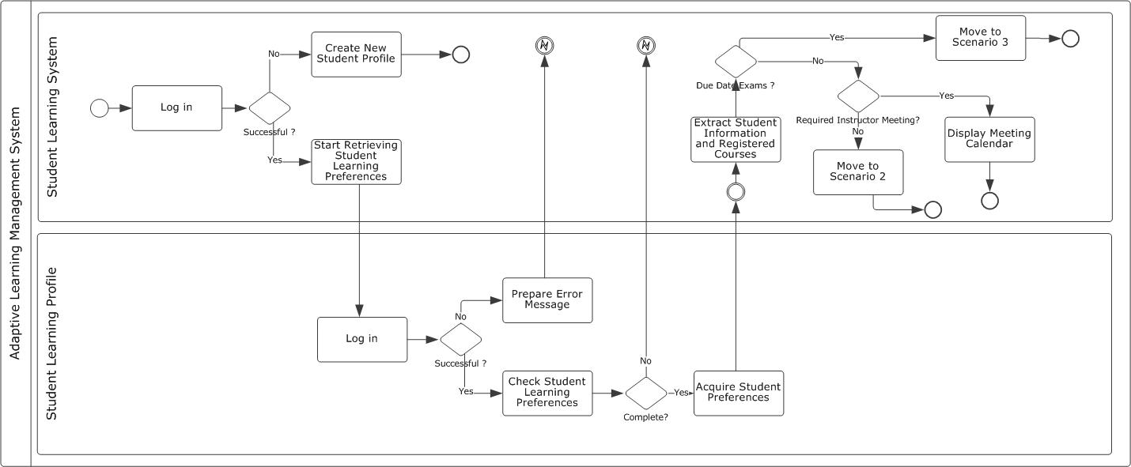

Figure 3.2: Scenario 1 of Adaptive e-Learning Model “New Student”

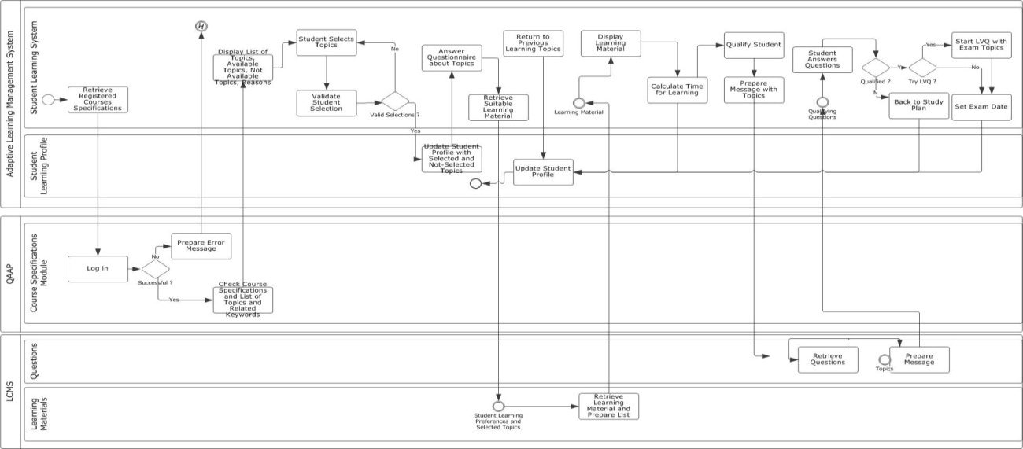

Figure 3.3: Scenario 2 of Adaptive e-Learning Model “Studying Student”

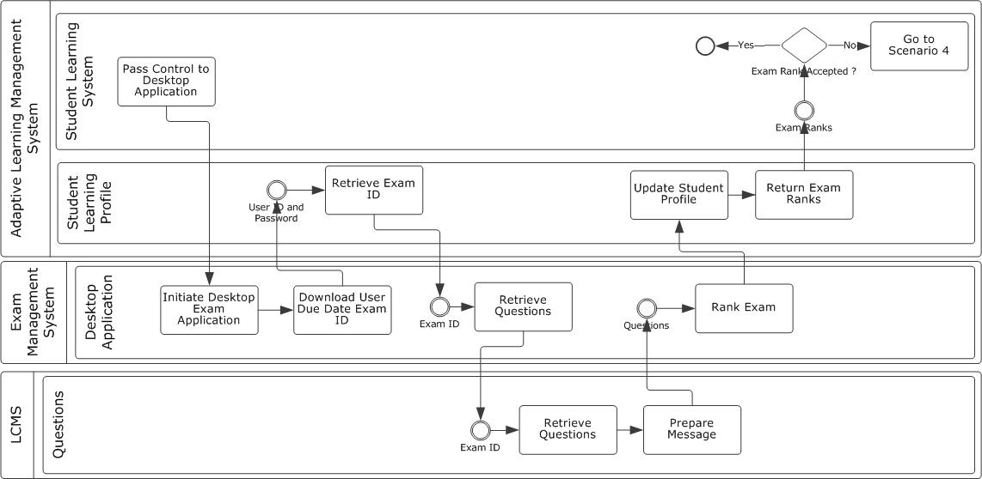

Figure 3.4: Scenario 3 of Adaptive e-Learning Model “Due Exam Student”

## 

Figure 3.5: Scenario 4 of Adaptive e-Learning Model “Suspended Student”

## Only the instructor can solve the situation after meeting the student by reactivating the student account after the proper action has been taken and recorded in the study profile. Instructor can illustrate the topic more than once to the student, examines student orally, written or whatever method the instructor finds appropriate. Figure 3.5 presents this scenario’s activities.

## Adaptive Features in Adaptive e-Learning Model

Figure 3.6 presents the complete adaptive e-Learning model. Adaptive features in proposed adaptive e-Learning model are many and include:

* Building learning profile and identifying learning preferences for each student using different methodologies.
* Checking student profile and learning preferences before recommending learning objects.
* Allowing the students to choose among the topics to learn within the constraints of the pre-requisites (partial control).
* Capability to arrange meetings for suspended students. Students are given the chance to self-study the subjects and attend the exams 3 times. If the student fails to pass the exam 3 times, a meeting must be arranged between the instructor and the student to submit a report by the instructor to the student profile, so the student can continue the learning process again in the adaptive way. This sort of blended learning gives strength to model.
* Providing the capability to calculate the required time to study a topic.
* Tracking students’ behaviour in the exams and attempting to identify cheating incidences.
* Integration with different online forum, wiki and blog services is available to enhance collaboration between students and encourage them to help each other. Facilities to enable online study groups - like chatting applications - are available.

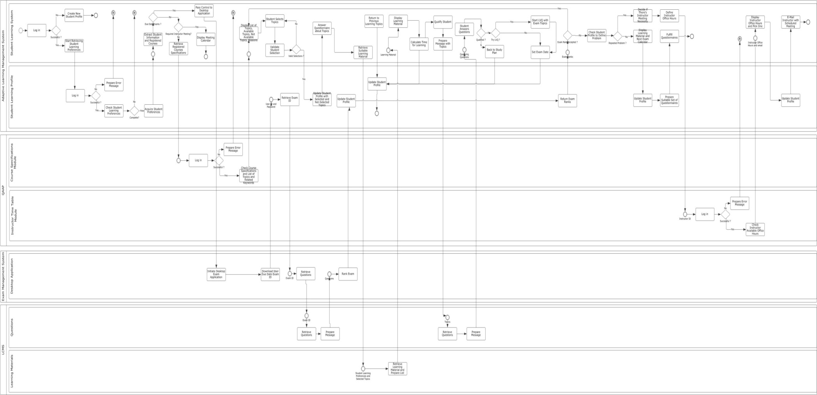

Figure 3.6: Complete Adaptive e-Learning Model

Table 3.1 presents a summary of the mapping between proposed adaptive features in the proposed learning model and the four adaptive learning approaches presented in chapter two – part one. In addition, the proposed model combines both Adaptable and Adaptive capabilities. Adaptability made available by giving students the capability to define and edit their personal preferences, which will affect directly their learning experience.

Table 3.1: Summary of Adaptive e-Learning Model Features and Adaptive Learning Approaches

|  |  |
| --- | --- |
| Adaptive Feature of the Proposed Model | Adaptive Learning Approach |
| Adaptation of Instructions on a Macro Level | Macro Adaptive Approach |
| Allowing Students to select among the topics to learn taking in consideration pre-requisites | Partial Control, Aptitude Treatment Interaction (ATI) Approach |
| Suspend Account and Arrange Meetings with Instructors based on Learning Situations | Aptitude Treatment Interaction (ATI) Approach |
| Online Forum, Wiki, Blog, Chatting, Grouping Services | Constructivistic – Collaborative Approach |

# Adaptive Online Lecture Model

The need for conducting and attending lectures in learning is clear for both students and instructors. Online meetings present the required audio and video communications with the capability to share presentations, desktop activities and transfer files. Different Online Meetings software and applications in both Web and desktop forms are available. However, their design and implementation were not aimed to be used for online lectures in the first place. Despite the tremendous advancement in technology that is witnessed by those applications, they still lack certain level of feedback from students to instructors that pushes students into more engagement within the learning process.

Engaging students in the lecture activities will enhance the students’ learning experience. Technically, this is available via extensive utilization of technologies that exist nowadays. During the online lecture, students are encouraged to give continuous informal feedback about different lecture activities via the same Web 2.0 technologies they are using. This feedback can be studied and analyzed later by the instructor. It can be used as an indicator on how the lecture was progressing, and know how to enhance the upcoming lectures. Formal feedback request can be initiated by the instructor periodically to test certain points about which the instructor needs to ensure as a “check point” before moving on to the next point. Involving students in different assignments and activities during the lecture is welcomed and needs to be recorded in the students learning profiles. Finally, preparing for the next lecture is not only the instructor’s responsibility. Pedagogically, the instructor is supposed to define the topics for the next lecture and the pre-requisites to learn these topics. Technically, LMS is supposed to check the student’s learning profile and preferences to define to what extent the student is familiar with those topics, and then providing the student with the learning materials. It is the responsibility of the student to study and examine these learning materials before the next lecture. Adaptive online lecture goals can be achieved in three phases.

### Phase One: Preparing Online Lecture

The students' learning models are not the same, and that will be considered while selecting the contents to be displayed during the Online Lecture. In order not to lose the student’s attention during the lecture, types of contents shall be mapped with both their direct feedback and learning profiles. Figure 3.7 presents the different activities required to fulfil this phase.

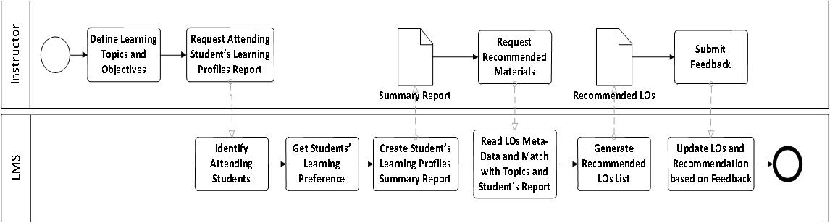

Figure 3.7: Recommend LOs for Instructor based on Analysis of Learning Profiles Process

### Phase Two: During Online Lecture

The Proposed Adaptive Online Lecture Model attempts to address: Order of Contents, Assessments, and Assignments and Collaborative as aspects of lecture activities.

* **Order of Contents:** Displaying the video file before / after discussing it or even twice in the lecture is one of the decisions that the instructor might not pay enough attention to, while it is important in keeping the students focused on the lecture activities. If the students are given some capability to re-order the contents of the lecture and discussions, they would feel the personalization of the Online Lecture, and would get deeply involved in the lecture.
* **Assessments:** Instructors might need to conduct one of the on the fly assessments to ensure that students have reached a basic level of knowledge regarding one of the topics they were discussing before moving on to the next topic.
* **Assignments and Collaboration:** Students attending the online lectures are already connected to the Internet via their laptops, they have accounts on multiple Web 2.0 collaboration tools providers, like Microsoft and Google, so they can easily transform to those tools based on the instructor’s directions. Their collaborative work can be marked and discussed online as if they are in a traditional lecture.

Figure 3.8 presents the proposed Activity Diagram of the During Lecture activities that allows students to submit informal feedback during lecture.

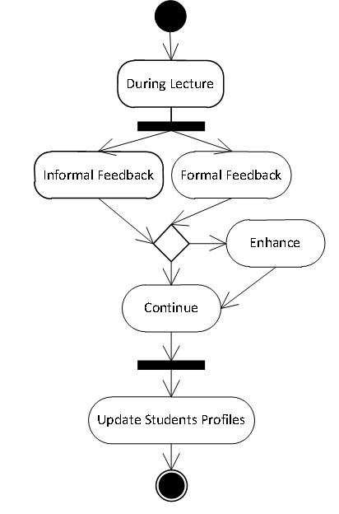

Figure 3.8: Formal and Informal Feedback Processes Synchronization during Lecture

### Phase Three: Upcoming Lecture

Before the students leave the current lecture, the instructor shall ensure that they are familiar with the prerequisites of the upcoming lecture. Proposed Adaptive Online Lecture can facilitate this by conducting assessments for the students and ask them clearly about the prerequisites, or by checking their learning profiles. Proposed Adaptive Online Lecture Model can access the Student Profile and Online Preferences for data about their previous attended sessions, courses, specifications and other details. In case one of the students does not satisfy the requirements defined by instructor, a personalized content can be generated for that student via Intelligent LOs Recommender, and then the student's interaction with those materials is tracked. Figure 3.9 presents the different system activities to support the adaptive LOs recommendation.

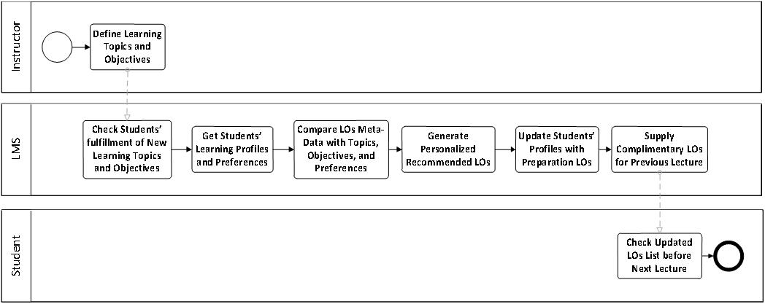

Figure 3.9: Recommend LOs for Students based on Upcoming Lecture Topics and their Preferences

# IT Architecture to Enable Presented Adaptive Models

IT architecture needed to support both the adaptive e-Learning model and the adaptive online lecture model is complex and includes the utilization of different technologies. SOA utilization has many advantages in solving integration challenges. IT architecture includes the following servers as presented in figure 3.10. Servers are grouped into four groups based on their functionality:

1. Utility, Middleware, and Load Balancing
2. Adaptive LMS
3. Learning Content Management System and Content Servers
4. Adaptive Online Lecture
   * 1. **Utility, Middleware, and Load Balancing Servers**

This category includes servers responsible for security, authentication and authorization, middleware, and load balancing. Servers include:

* **Proxy and Firewall Server** acts as the gate between online and external systems, and the rest of Servers.
* **Identity and Log in Server** shall be added to enable single sign-on authentication and authorization capabilities for the whole solution. It helps avoid the repeated Log-in process between different applications and servers.
* **Middleware:** Responsible for managing Quality of Service (QoS) and directing messages among different components of the systems.
* **Web services Application Server**: shall be added to hold Web services responsible mainly for:
* **Data Adapter**: Accessing data stored at QAAP, and external systems.
* **Integration and Interoperability:** Between different servers based on different required functionalities.
  + 1. **Learning Content Management System and Content Servers**

This category addresses the Learning Objects characteristics, meta-data, recommendation process, and the Learning Content Administration System (LCAS). Servers in this category include:

* **LCMS and Content Servers:** Logically, the following servers are required to manage the presented functionalities:
* **Learning Content Server:** To hold the learning materials physical files. Different implementation can include FTP Server.
* **Learning Content Data and Meta-Data Repository:** To maintain data and meta-data about learning materials. The data will be used to determine the appropriate learning materials for the students.
* **Learning Content Administration System (LCAS):** Holds the application that enables administrators to manage learning content files, learning content data and learning content meta-data.
* **Exam Management Server:** Manages exam process and accesses LCMS questions based on exam IDs.
* **Learning Content Recommender:** Works on the learning contents data, meta-data, students learning profiles, students learning history, and instructors’ recommendations in order to recommend learning materials to students.
  + 1. **Adaptive LMS Servers**

Adaptive LMS is responsible for providing adaptive functionalities presented in the adaptive e-Learning model and providing the main interface for students to access the Web application. This category include:

* **Adaptive LMS Application Server:** Holds the portal that can be accessed by students.
* **Adaptive LMS Database Server:** Holds the student profiles, learning preferences and learning history.
  + 1. **Adaptive Online Lecture Servers**

This category includes the required servers to support the Adaptive Online Lecture model, which are:

* **Collaboration, Assessments and Assignments:** Main components of the Learning Process that are maintained separately to provide greater flexibility and the ability to utilize different technologies.
* **Real-Time Communication Server:** Responsible for providing communications functionalities between instructors and students, and the students and each other. It manages Online Lecture file, desktop, text sharing, other activities and Web 2.0 technologies that will be used in the Informal Feedback.
* **Analyzer and Report Generator:** Responsible for analyzing gathered data and generating appropriate reports to help instructors take the appropriate decisions.

# Integration of Proposed Models Services Via SOA

A combination of both Business Process Management and SOA is proven to achieve numerous advantageous features for systems. Proposed adaptive e-Learning model presents an adaptive process that changes based on students' performance. SOA is the utilized software architecture in building the system and in integrating different components required to support the adaptive models. Services are the building blocks of SOA, and proposed model services can be categorized in the layers depicted in figure 3.11. The four layers are:

* **Orchestration Layer:** holds services responsible for maintaining learning process logic and activities. It includes services that utilize both composite services’ layer services, and data services’ layer services.
* **Composite Services:** are services that hold other services and don’t complete functioning unless all composing services execute successfully; however it is not controlling them.
* **Data Services Layer (Information as a Service “IaaS”):** is the layer that holds services responsible for transforming Meta-data into meaningful information to other utilizing information systems, instructors, and students.
* **Model Layer (Database):** it is the database layer that holds data tables.

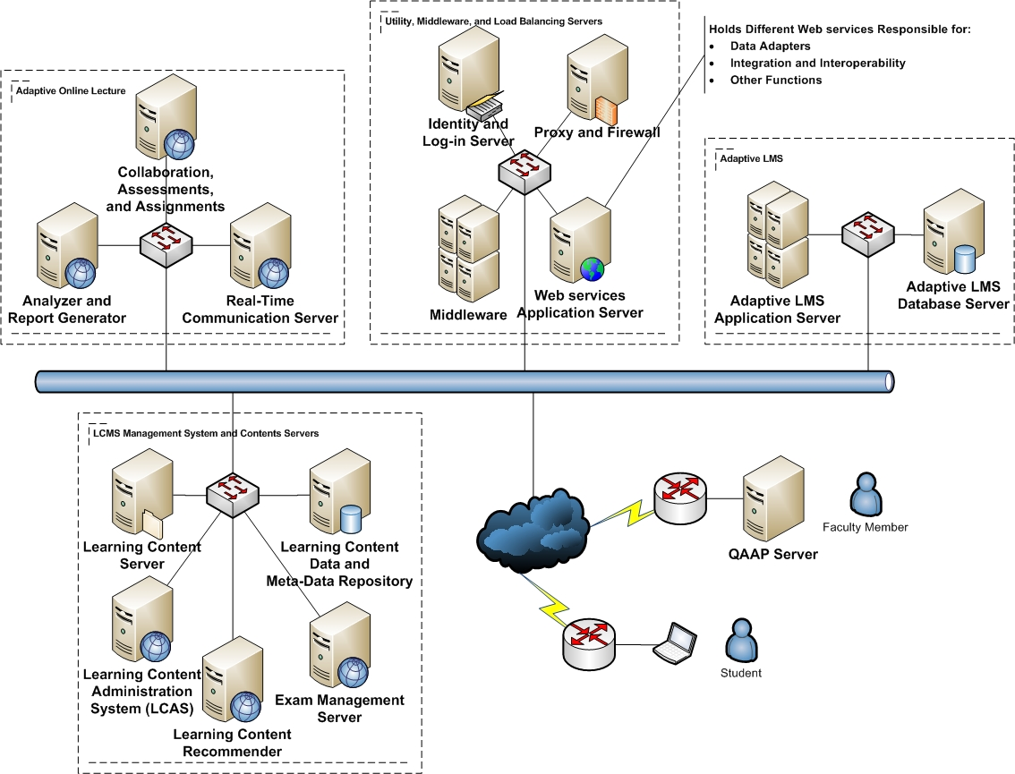

Figure 3.10: IT Architecture Specifications to Enable Presented Adaptive Models



Figure 3.11: Proposed Model Layered Architecture

Table 3.2 presents a summary of presented services, applied to IT architecture to highlight the implementation of the services, and identify how services utilize each other. Table 3 layers are:

* **Orchestration Layer:** holds services responsible for maintaining learning process logic and activities. It includes services that utilize both composite services’ layer services, and data services’ layer services.
* **Composite Services:** are services that holds other services and don’t complete functioning unless all composing services execute successfully; however it is not controlling them
* **Data Services Layer (Information as a Service “IaaS”):** holds services responsible for transforming Meta-data into meaningful information to other information systems, instructors, and students. Data adapters for accessing external systems are presented in this layer. QAAP data adapter for example is presented for accessing QAAP.
* **Model Layer (Database):** it is the database layer that holds data tables.

Table 3.2: Model Services, Categorized by Architecture Layers, and Mapped to IT Infrastructure

|  |  |  |  |  |
| --- | --- | --- | --- | --- |
| Design Layer | Service Name | Parent System | NW Diagram Server | Utilized Services |
| Orchestration Layer (Controller) | **O1:** Search for LO | Adaptive LMS | Adaptive LMS | C1,C2 |
| **O2:** Intelligent LOs Recommender | Adaptive LMS | Adaptive LMS | D2, D3, D4, D5 |
| **O3:** LVQ | LVQ | Adaptive LMS |  |
| **O4:** Intelligent Meeting Manager for Suspended Students | Adaptive LMS | Adaptive LMS | D5,D10 |
| **O5:** Intelligent Study Plan Advisor | Adaptive LMS | Adaptive LMS | D2, D4, D5 |
| **O6:** Intelligent Time-to-Learn Topic | Adaptive LMS | Adaptive LMS | D3, D4, D5 |
| **O7:** Intelligent Online Lecture LO Classifier | Adaptive LMS | Adaptive LMS | D1, D4, D5, D10 |
| **O8:** Intelligent Student Tracker | Adaptive LMS | Adaptive LMS | D5 |
| **O9:** Intelligent Cheat Depressor | Adaptive LMS | Adaptive LMS | D5, D6, D7 |
| **O10:** Intelligent Agenda Time Planner | Adaptive LMS | Adaptive LMS | D1, D2, D3, D4, D5 |
| **O11:** Recommend LOs for Lecture | Adaptive Online Lecture | Learning Content Recommender | D1, D5 |
| **O12:** Prepare Next Lecture | Adaptive Online Lecture | Learning Content Recommender | D1, D5 |
| **O13:** Formal Feedback | Adaptive Online Lecture | Collaboration, and Assessment Server |  |
| **O14:** Informal Feedback | Adaptive Online Lecture | Real-Time Communication | C2 |
| **O15:** Generate Lecture Report | Adaptive Online Lecture | Analyzer and Report Generator |  |
| **O16:** Satisfy Student Missing Pre-requisites | Adaptive Online Lecture | Learning Content Recommender | D1, D5 |
| Composite Services | **C1:** Intelligent LOs Classifier | LCMS | Learning Content Recommender | D1,D5 |
|  | **C2:** Gather Informal Feedback | Adaptive Online Lecture | Analyzer and Report Generator | D11 |
| Data Services Layer (IaaS) | **D1:** Learning Objects Manager | LCMS | LCAS | DB1 |
| **D2:** Lessons Manager | Adaptive LMS | Adaptive LMS | DB2 |
| **D3:** Topics Manager | Adaptive LMS | Adaptive LMS | DB2 |
| **D4:** Course Manager | Adaptive LMS | Adaptive LMS | DB2 |
| **D5:** Student Profile Manager | Adaptive LMS | Adaptive LMS DB Server | DB3 |
| **D6:** Questions Manager | LCMS | Exams Management | DB4 |
| **D7:** Exams Manager | LCMS | Exams Management | DB4 |
| **D8:** Questionnaires Manager | Adaptive LMS | Adaptive LMS | DB3 |
| **D9:** Course Module Adapter | QAAP | Web Services Application Server | -- |
| **D10:** Instructor Data Adapter | QAAP | -- |
| **D11:** Social Networks Data Adapter | Social Network Sites | -- |
| **D12:** Assignments Manager | Adaptive LMS | Adaptive LMS | DB5 |
| **D13:** Assessments Manager | Adaptive LMS | Adaptive LMS | DB5 |
| Model Layer (Databases) | **DB1:** Learning Objects | LCMS | Learning Content Repository | -- |
| **DB2:** Lessons, Topics and Courses | Adaptive LMS | Adaptive LMS DB Server | -- |
| **DB3:** Student Profiles and Questionnaires | Adaptive LMS | Adaptive LMS DB Server | -- |
| **DB4:** Questions and Exams | LCMS | Exams Management | -- |
| **DB5:** Assignments and Assessments | Adaptive Online Lecture | Collaboration, Assessments, and Assignments | -- |

# Learning Objects in Presented Adaptive Models

Learning Object (LO) is the basic building block of a learning resource; it is the electronic representation of media, such as text, images, sounds, assessment objects or any other piece of data that can be rendered by a Web client and presented to a learner. LOs play an important role in the proposed system to present different adaptivity features, hence the need to specify a standalone system to manage it, which is Learning Content Management System (LCMS). LO’s meta-data needed to support the adaptivity features are presented in details in table 3.3 highlighting the focus area of each category and presenting the needed attributes to be stored for each category. LOs meta-data grouped into:

* **General:** Groups general information that describe LOs as a whole.
* **Lifecycle:** Groups the features related to the history and current state of LO and those who have affected the component during its evolution.
* **Technical:** Describes technical characteristics and requirements of LO.
* **Educational:** Describes educational or pedagogic characteristics of LO.
* **Rights:** Describes intellectual property rights for LO.
* **Annotation:** Provides comments on the educational use of LO.
* **Classification:** Describes where LO falls within a classification system.

Table 3.3: LO’s Meta-Data Categories, Attributes, and Description

|  |  |  |
| --- | --- | --- |
| Category | Attribute | Description |
| General | Groups the general information that describes LO as a whole. | |
| Identifier | Represents a mechanism for assigning a globally unique label that identifies LO. |
| Catalog | Represents the name or designator of the identification or cataloging scheme for LO. There are a variety of cataloging systems available. Some types of cataloging systems:   * Universal Resource Identifier (URI) * Universal Resource Name (URN) * Digital Object Identifier (DOI) * International Standard Book Numbers (ISBN) * International Standard Serial Numbers (ISSN) |
| Title | Name given to the LO. |
| Language | Primary language or languages used in LO . |
| Description | Textual description of LO. |
| Keyword | Define common keywords that describe LO. |
| Coverage | Describe the time, culture, geography or region to which the LO applies. |
| Structure | Describe the underlying organizational structure of LO. Values are:   * Atomic: Object that is indivisible. * Collection: Set of objects with no specified relationship between them. * Networked: Set of objects with relationships that are unspecified. * Hierarchical: Set of objects whose relationships can be represented by a tree structure. * Linear: Set of objects that are fully ordered. |
| Aggregation Level | Describe the functional granularity of LO. Values are:  1: The smallest level of aggregation, e.g., raw media data or fragments.  2: A collection of level 1 LOs, e.g., a lesson.  3: A collection of level 2 LOs, e.g., a course.  4: The largest level of granularity, e.g., a set of courses that lead to a certificate. |
| Life Cycle | Groups the features related to the history and current state of LO and those who have affected the component during its evolution. | |
| Version | Describes the edition of LO. |
| Status | Describe the completion status or condition of LO. Values are:   * Draft: The component is in a draft state (as determined by the developer). * Final: The component is in a final state (as determined by the developer). * Revised: The component has been revised since the last version. * Unavailable: The status information is unavailable. |
| Contribute | Describe those entities (i.e., people, organizations) that have contributed to the state of LO during its lifecycle. |
| Role | Defines the kind or type of contribution made by the contributor (identified by the Entity element). Values are:   * author * publisher * unknown * initiator * terminator * validator * editor * graphical designer * technical implementer * content provider * technical validator * educational validator * script writer * instructional designer * subject matter expert |
| Date | Identifies the date of the contribution. |
| Technical | Describes all of the technical characteristics and requirements of LO. | |
| Format | Represents the technical datatype(s) of all of the components used in the makeup of the LO. |
| Size | Represents the size of LO in bytes. |
| Location | Specifies the location of LO.  . |
| Requirement: | Expresses the technical capabilities necessary for using LO. |
| Type | Represents the technology required to use LO (e.g., hardware, software, network, etc.). Vocabulary token include:   * Operating system * Browser |
| Name | Represents the required technology to use LO. |
| Minimum Version | Represents the lowest possible version of the required technology to use LO. |
| Maximum Version | Represents the highest possible version of the required technology to LO. |
| Installation Remarks | Used to represent any specific instructions on how to install LO. |
| Other Platform Requirements | Used to represent information about other software and hardware requirements. |
| Duration | Represents the time a continuous LO takes when played at intended speed. This element is useful for sounds, movies, simulations and the like. |
| Educational | Describes the key educational or pedagogic characteristics of LO. This category is typically used by teachers, managers, authors and learners. | |
| Interactivity Type | Represents the dominant mode of learning supported by LO. Vocabulary tokens:   * **Active**: Active learning (e.g., learning by doing) is supported by content that directly induces productive action by the learner. * **Expositive**: Expositive learning (e.g., passive learning) occurs when the learner’s job mainly consists of absorbing the content exposed to them. * **Mixed**: A blend of active and expositive interactivity types. |
| Learning Resource Type | Represents the specific kind of LO. Vocabulary tokens:   * Exercise * Simulation * Questionnaire * Diagram * Figure * Graph * Index * Slide * Table * Narrative text * Exam * Experiment * Problem statement * Self-assessment * Lecture |
| Interactivity Level | Represents the degree of interactivity characterizing LO. Interactivity refers to the degree to which the learner can influence the aspect or behavior of LO. Vocabulary tokens:   * Very low * Low * Medium * High * Very high |
| Intended End User Role | Represents the principal user(s) for which LO was designed. Vocabulary tokens:   * Teacher * Author * Learner * Manager |
| Context | Represents the principal environment within which the learning and use of LO is intended to take place. Vocabulary tokens:   * School * Higher Education * Training * Other |
| Typical Age Range | Represents the age of the typical end user. Value should be formatted as *minimum age – maximum age*. |
| Difficulty | Represents how hard it is to work with or through LO for the typical intended target audience. Vocabulary element:   * Very easy * Easy * Medium * Difficult * Very difficult |
| Typical Learning Time | Represents the approximate of typical time it takes to work with or through LO. |
| Description | Used to comment on how the LO. |
| Language | Represents the human language used by the typical intended user of LO. |
| Rights | Describes the intellectual property rights and conditions of use for LO. | |
| Cost | Represents whether the LO requires some sort of payment. Vocabulary tokens:   * Yes * No |
| Description | Allows comments on conditions of use of LO. |
| Annotation | Provides comments on the educational use of LO and information on when and by whom the comments were created. This category enables educators to share their assessments of LO. | |
| Entity | Identifies the entity created the annotation. |
| Date | Identifies the date the annotation was created. |
| Description | Used to represent contents of the annotation. |
| Classification | Describes where LO falls within a particular classification system. Multiple Classification categories may be used. | |
| Purpose | Defines the purpose for classifying LO. Vocabulary Tokens:   * Discipline * Idea * Prerequisite * Educational Objective * Accessibility Restrictions * Educational Level * Skill Level * Security Level * Competency |
| Description | Represent content of classification. |

* 1. **Exam Management System and Cheating Challenges**

One of the utilized e-Learning activities is “Online Assessments”. Although Online Assessments are not the only criteria to qualify students, it is still an important feature to be activated. One of the problems that prevent e-Learning from gaining advantages of Online Assessments is “Leak of Assessments”. Students search the internet for assessments’ questions and answers, and unfortunately they can easily find them. Of course it is the students’ choice to either follow those answers or not. No matter how close the instructor to the students, they will not confess “cheating”. Online Assessments are not conducted in a secure and supervised environment most of the time. Here, analysis results of online assessment experiment are presented to address online assessment challenges and present solutions. During analysis of the assessments’ results, some facts become clear. One of the results that forced the analysis of assessments’ data was the noticeable number of students who finished the assessment in less than 10 minutes and acquired more than 30 out of 50 as a mark. The assessment consists of 50 True/False questions. Those questions are very well prepared; some of them are accessible via the resources available from the book author(s), and the rest are prepared internally. It was shocking to find that the number of students that got high grades in an almost “not enough time to read the questions” is high. Luckily, students do not know that the system records start-time and end-time, and it can easily calculate duration, or they would have spent longer times just pretending to be solving the assessment.

### Problem Domain Analysis

This section holds the analysis results of the online assessment conducted in the academic year 2010 in Information Systems Department, Faculty of Computers and Information Sciences, Mansoura University, Egypt. Figure 3.12 presents the percentage of students with variant assessment completion times. There are 223 students enrolled in this course with 209 online active users. The number of students who attended the first assessment was 182. Students are classified into 7 groups based on the assessment time as presented in table 3.4. The strange notice was that almost two third of the students conducted the assessment in less than 20 minutes.

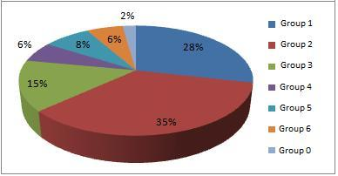

Figure 3.12: Percentage of Students per Assessment Time

Table 3.4: Different Students Groups in this Section

|  |  |
| --- | --- |
| Group 0 | Students started but did not complete the assessment and will not be mentioned anymore in this study |
| Group 1 | Students conducted the assessment in duration less than 10 minutes. |
| Group 2 | Students conducted the assessment in duration between 10 and 20 minutes. |
| Group 3 | Students conducted the assessment in duration between 20 and 30 minutes. |
| Group 4 | Students conducted the assessment in duration between 30 and 40 minutes. |
| Group 5 | Students conducted the assessment in duration between 40 and 50 minutes. |
| Group 6 | Students conducted the assessment in duration between 50 and 60 minutes. |

To verify the situation, the marks average of each group was calculated and again the results clearly indicate something that is not as “planned to be” situation. Figure 3.13 depicts the average of the six different groups with the notice that averages are almost the same. That means there are students who solved the assessment in less than 10 minutes with marks close to - and may exceed sometimes - those who solved it in almost an hour. To be sure about the grading issue, further analysis to the results was applied with the result that: Number of students from all groups who scored between 0 and 10 out of 50 is (zero). The number of students from all groups who scored between 10 and 20 is only (one). Figure 3.14 shows the different counts of different groups for marks between 20 and 30. Figure 3.15 and figure 3.16 shows the different number of students with marks between 30 and 40, and 40 and 50 respectively.

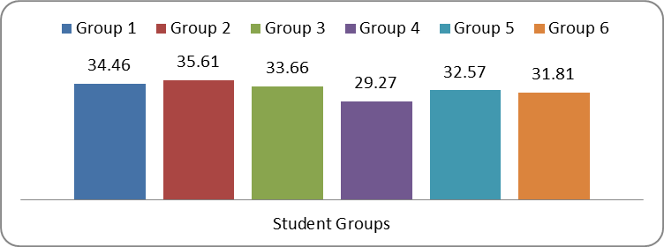

**Figure 3.13: Bar Graph of Marks Average per Different Student Groups**

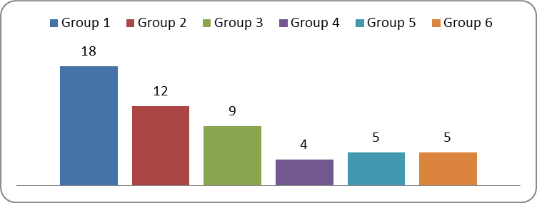 **Figure 3.14: No. of Students Achieving Grade Range from 20 to 30 Categorized by Group**

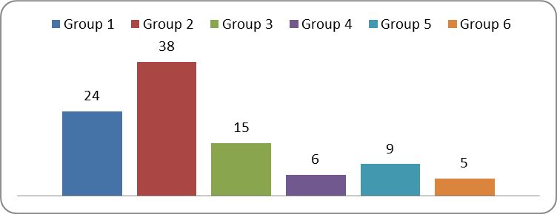 **Figure 3.15: No. of Students Achieving Grade Range from 30 to 40 Categorized by Group**

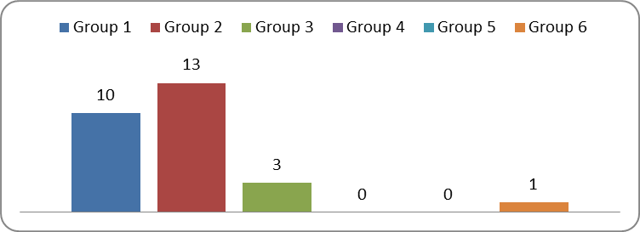

**Figure 3.16: No. of Students Achieving Grade Range from 40 to 50 Categorized by Group**

* + 1. **Comparative Study between Supervised and Non-Supervised Quizzes**

To take a further look on the problem, six different quizzes was conducted in the academic year 2010 to compare between students’ performance in both supervised and non-supervised quizzes. Each quiz was conducted twice, once in a supervised environment, and another in non-supervised environment. Students behavior and scored marks are recorded. Table 3.5 presents further details on the types of those quizzes. Table 3.6 presents groups distribution for each quiz.

Table 3.5: Statistics about the Six conducted quizzes in 2009-10

|  |  |  |  |  |  |  |
| --- | --- | --- | --- | --- | --- | --- |
|  | 1st Quiz | 2nd Quiz | 3rd Quiz | 4th Quiz | 5th Quiz | 6th Quiz |
| Quiz Title | Quiz 1 | Quiz 2 | Quiz 3 | Quiz 4 | Quiz 5 | Quiz 6 |
| Total Marks | 50 | 50 | 25 | 50 | 50 | 50 |
| Total No. of Questions | 50 | 50 | 20 | 50 | 50 | 50 |
| Types of Questions | T/F | MCQ | Match | Mix | Mix | Mix |
| Overall Difficulty Level | Med. | Med. | Med. | Med. | Med. | Med. |
| T/F Questions | 50 | 0 | 0 | 20 | 20 | 20 |
| Easy T/F Questions | 5 | 0 | 0 | 2 | 2 | 3 |
| Medium T/F Questions | 35 | 0 | 0 | 14 | 17 | 17 |
| Hard T/F Questions | 10 | 0 | 0 | 4 | 1 | 0 |
| Multi Choice Questions | 0 | 50 | 0 | 10 | 10 | 10 |
| Easy MCQs | 0 | 3 | 0 | 0 | 0 | 1 |
| Medium MCQs | 0 | 39 | 0 | 8 | 9 | 8 |
| Hard MCQs | 0 | 8 | 0 | 2 | 1 | 1 |
| Match Questions | 0 | 0 | 20 | 20 | 20 | 20 |

Table 3.6: Detailed Quizzes’ Statistics

|  |  |  |  |  |  |  |  |  |  |  |  |  |
| --- | --- | --- | --- | --- | --- | --- | --- | --- | --- | --- | --- | --- |
|  | 1st Quiz | | 2nd Quiz | | 3rd Quiz | | 4th Quiz | | 5th Quiz | | 6th Quiz | |
|  | On-line | Lab | On-line | Lab | On-line | Lab | On-line | Lab | On-line | Lab | On-line | Lab |
| Total | 212 | 212 | 212 | 212 | 212 | 212 | 212 | 212 | 212 | 212 | 212 | 212 |
| Enrolled | 167 | 46 | 170 | 45 | 166 | 50 | 160 | 69 | 155 | 66 | 153 | 65 |
| Time Avg. | 24.8 | 16.8 | 26.4 | 21.4 | 7.8 | 3.6 | 22 | 15 | 17 | 15 | 15.4 | 12.7 |
| Marks Avg. | 39.5 | 29.9 | 39 | 26 | 22 | 15.7 | 35 | 26 | 43.6 | 30 | 42.8 | 21.8 |
| Group 0 | 29 | 0 | 21 | 0 | 5 | 2 | 14 | 0 | 14 | 0 | 13 | 0 |
| Group 1 | 23 | 10 | 22 | 2 | 130 | 38 | 36 | 21 | 37 | 20 | 44 | 29 |
| Group 2 | 40 | 27 | 33 | 20 | 23 | 10 | 41 | 27 | 63 | 32 | 66 | 24 |
| Group 3 | 34 | 5 | 37 | 18 | 7 | 0 | 37 | 17 | 25 | 10 | 17 | 10 |
| Group 4 | 13 | 1 | 26 | 4 | 1 | 0 | 13 | 4 | 7 | 3 | 8 | 1 |
| Group 5 | 14 | 2 | 20 | 1 | 0 | 0 | 7 | 0 | 5 | 1 | 3 | 1 |
| Group 6 | 14 | 1 | 11 | 0 | 0 | 0 | 12 | 0 | 4 | 0 | 2 | 0 |

Figure 3.17, 3.20, 3.23, 3.26, 3.29, 3.31 presents groups’ distribution for the six quizzes respectively. Figures 3.18, 3.21, 3.24, 3.27, 3.30, 3.32 present time comparison between supervised and non-supervised students for the six quizzes respectively. Figures 3.19, 3.22, 3.25, 3.28, 3.31, 3.33 present the scored marks comparison between supervised and non-supervised in the six quizzes respectively. Analyzing students’ consumed time and scored marks for the six quizzes, and comparing both the supervised and non-supervised environments results in two noticeable things: students spend longer times in online (non-supervised environments), and score higher marks in online quizzes. That might be used as an indication of cheating. To take a closer look on the issue, a closer study of the intersection students between both supervised and non-supervised students is presented. 24 students fall in the intersection.

Figures 3.35, 3.36, 3.37, 3.38, 3.39, 3.40 show comparison for intersecting students for each quiz respectively comparing: Online Time, Online Marks, Lab Time, Lab Marks. Students spend longer times in online quizzes and score higher marks when compared to lab times. Tracking students’ behavior intelligently can be useful in identifying cheating incidences and notifying instructors’ of their occurrences.

|  |  |  |
| --- | --- | --- |
| Figure 3.17:  Quiz 1 Groups’ Percentage Comparison | Figure 3.18:  Quiz 1 Time Consumption Comparison | Figure 3.19:  Quiz 1 Scored Marks Comparison |
| Figure 3.20:  Quiz 2 Group's Percentage Comparison | Figure 3.21:  Quiz 2 Time Consumption Comparison | Figure 3.22:  Quiz 2 Scored Marks Comparison |
| Figure 3.23:  Quiz 3 Group's Percentage Comparison | Figure 3.24:  Quiz 3 Time Consumption Comparison | Figure 3.25:  Quiz 3 Scored Marks Comparison |
| Figure 3.26:  Quiz 4 Group's Percentage Comparison | Figure 3.27:  Quiz 4 Time Consumption Comparison | Figure 3.28:  Quiz 4 Scored Marks Comparison |
| Figure 3.29:  Quiz 5 Group's Percentage Comparison | Figure 3.30:  Quiz 5 Time Consumption Comparison | Figure 3.31:  Quiz 5 Scored Marks Comparison |
| Figure 3.32:  Quiz 6 Group's Percentage Comparison | Figure 3.33:  Quiz 6 Time Consumption Comparison | Figure 3.34:  Quiz 6 Scored Marks Comparison |

|  |  |
| --- | --- |
|  |  |
|  |  |
| Figure 3.35: Quiz 1 Defined Intersection Students | Figure 3.36: Quiz 2 Defined Intersection Students |
| Figure 3.37: Quiz 3 Defined Intersection Students | Figure 3.38: Quiz 4 Defined Intersection Students |
| Figure 3.39: Quiz 5 Defined Intersection Students | Figure 3.40: Quiz 6 Defined Intersection Students |

### Comments on Results

Here are some cheating tips that have been witnessed during students’ monitoring and feedback:

* **Access to Answers’ Files:** Open the assessment PDF or document file, search for keywords, and immediately apply answers. Most students have high memorable capabilities regarding mapping questions and answers.
* **Collaborative Solution:** Though collaboration is really important in the learning process, this way of collaboration to cheat was really new. More than one student conducts the assessment. One holds the laptop, others hold different pages of the assessment answers, so they optimize the search time, and the one holding the laptop says the question loudly and of course students can find answers in no time. Of course in Non-Supervised   
  e-Learning environment, there is no way to guarantee that students themselves attended the assessment.

Two categories of students must not be neglected to assure certain learning quality level:

* **Careless Students:** They do not really need to read the assessment questions. They only pick an answer and they don’t care about the results. There are students who answered 50 questions in less than 3 minutes, which gives them an average reading of 3.6 seconds for each question. Another form of carelessness was presented in the 4 students (out of 182 that is almost 2%) who did not finalize the assessment.
* **Not Interested Students:** Almost 23% of the course enrolled students (41 students out of total 223 students) did not attend any of the e-Learning activities. This percentage is huge, and in our course, it is not acceptable at all. However, motivating students to attend Learning activities is always a challenge.

### Proposed Solution to Cheating Problems

Based on results presented in the aforesaid section, it is clear that there are issues that shall be considered before providing students with online exams. There must be a stronger way of controlling the Exam process in order to make marks more trustable. Proposed Solution tips to this issue are many. More studies about efficiency and effectiveness of each one need to be conducted and further analyzed and studied. Those actions can be categorized into two categories: Educational and Technical solutions. The solution includes Pedagogical and Technical aspects.

### Pedagogical Proposed Solution Aspects

Pedagogical Solutions include the attempt to present an unlimited Assessment Items Repository, and to track the students’ progress during the learning process, so peaks can be determined and be a mark for inappropriate activity during the learning process. Also, a timed question is almost a must in the exam process. Timer shall not only start after the student sees the question, we are thinking about calculating time for both displaying and solving the question. Therefore, theoretically, students shall never find time to cheat. This study proposes some tips that can be used as solutions that focus on four aspects of the online assessment process and can be thought of as the integration of the all:

* **Questions Based Solution:** Assessments banks should consist of larger number of questions with the chance to have 1/4 or 1/3 the assessment different from one student than the other. Also, instructors should work on updating assessments banks and keeping them out of reach for students.
* **Environment Based Solution:** This solution is complimentary to the previous suggested one. Supervised e-Learning environments are important, and simply are the only way to guarantee certain accepted level of learning quality. Students can find the time to search the answer files because they can access them easily. Hopefully when students do not have access to such files, they might learn better.
* **Assessment Based Solution:** Timer that forces students to read questions before viewing the answers might be a good idea. Maybe by forcing students to wait for answers before selecting one of them will be a catalyst for the student to read the questions and all the answers. Though this is not a guarantee, but it might be a good way to do so.
* **Student Based Solution:** It is important to discuss with students the importance of e-Learning activities in the learning process, and the gains they can easily acquire and make use of via utilizing such activities. The attempt to qualify students’ culture with e-Learning is important to start gaining e-Learning advantages. Yet, not all students believe in e-Learning; only 182 out of 223 cared about attending the online course activities. The rest needs to be talked to instead of neglecting them.

Most students do their best to play it smart, even if they will not follow the rules. Solutions to guarantee learning efficiency and effectiveness for current situations must be thought of about regularly. Unfortunately, students usually advance instructors in utilizing technology for their purposes, which might be “cheating”. We - as instructors - need to evaluate the situation regularly and rely more on student performance analysis tools to find out the unclear facts.

### Technical Aspects of the Solution

Technical Solutions are a real challenge. There is no Web based assessment system that presented a clear solution to such a problem. The solution lies in a well-controlled desktop application that must be used in the Exam process. Desktop applications provide techniques that are not available via Web based systems. Those techniques include:

* **Keyboard Hooking:** The desktop application can control keyboard strikes on system basis and not on application basis. So, we can control which keys are available for students to click and which are not. However, such solution is applicable for Microsoft Windows based Desktop Applications only, as Java Virtual Machine (JVM) does not provide such control over the Operating System, and that will stop authors from developing a platform independent Exam Desktop Application.
* **Operating System Log File:** The desktop application can check the Operating System Log file, and when it finds that the student executed any of the non-authored applications during the exam, it exits the exam. However, students can be smart enough to use two computers during the exam: one for taking the exam, and another for cheating. Besides, checking the Log file will be a time based process that is not guaranteed to take place anytime.
* **Check Running Processes:** The desktop application will check the running processes on the system before and during the exam, and will exit any non-exam required process that is running during the exam. This technique seems to be the most appropriate technique; however, building this list of processes will take time and effort.

By combining the above mentioned techniques - both pedagogical and technical - better circumstances during exams will be achieved.

* 1. **Summary**

Adaptive Online Lecture Model is presented to help instructors present an enhanced e-Learning experience to students. Adaptive Online Lecture tends to engage students in lecture activities from the very beginning of the lecture, help instructors prepare lecture by recommending the most suitable set of LOs to be used in the lecture. Adaptive Online Lecture also encourages students to submit informal feedback on the lecture activities, and provides an infrastructure to collect, analyse, and generate reports to instructors to be used to fine tune the lecture. IT architecture needed to enable presented adaptive models is discussed in details in this chapter addressing the needed server components, and how to integrate all of them using SOA. SOA is the design pattern that fits the integration among different systems task, and it is addressed in this chapter through the layered architecture. Detailed mapping between the different layers, servers, and presented systems and databases is presented highlighting services dependencies.

The chapter addresses the online assessment challenges that e-Learning faces. Challenges include cheating as the main threat to online assessments efficiency. By studying the behaviour of students on an online assessment, chapter ends with both pedagogical and technical recommendations to overcome the online assessments challenges.